***Abstract*— This Navigo Application with AI Project is an online application which helps the end users to find the information related to the location by scanning or uploading pictures which is taken as an input and shows the address details, travel duration, office hours, by redirecting to google api website. Our main concept is to give the best and quick result to the user with free of cost, so users can register, and request required information or access locations.. This application is reliable to users with the advanced data storage system, and allowing fastest search time and interaction. Hence, Navigo App looks attractive, because it is lightweight, free, and does not require a pre-deployed infrastructure. However, it needs a preparation phase, to create the map of magnetic fields and calibrate smartphones. This technical paper shows the flow of Navigo application.**

**Keywords— Location Based Services, Navigo API; data ; Artificial Intelligence as AI ; Application as App; Newyork; Smartphone Application; upload/scan; New York .**

**1. INTRODUCTION**

This application is a navigation web application where the users can scan an image to get access to its information, according to his/her criteria of requirement. The admin manages user accounts, service requests and also updates the information catalog regarding the locations of New York by adding, updating, and deleting. The main objectives are – the system should have an admin and user login, the admin should have end to end authority, scan or upload picture options. The user then requests for the information as per the result. We also present a use-case, i.e. a navigation in Newyork; such app, called NavApp, guides users in locating the Pace University in New York , by scanning or uploading a picture or pace university. NavApp covers th**e** Downtown New York locations, namely mapping and positioning using, path planning, en-route assistance, time duration.

**2. LITERATURE REVIEW**

In this monotonous and materialistic world, where it is difficult to match the pace of the modern world everyone wants to receive a lot of information by doing just little. Today, technology is breaking down the barriers of how these tasks have traditionally been administered. In more and more organizations business practices are evolving in such a way as to blend new technologies as never before. Traditional typing is outnumbered by modern and evolving AI (Artificial Intelligence). The data will be stored properly in the database, which will help inview, alter, and update the information. Nowadays everything is available on the web easily and quickly but to get all the necessary information about a place one must have to navigate through a lot of webpages which can be cumbersome and tiresome for new users who do not know much about a given place. For example, If a person from Spain visits Yankee Stadium(New York City) to watch a game of soccer between New York City vs LA Galaxy, he might not be familiar with the stadium timings, different routes on how to get the destination, for him to find out all the necessary information he has to navigate through a lot of websites. Instead by just a picture he can get all these relevant information about the place in no time with the help of our web app. Our application will navigate through a web application where the users can scan an image to get access to its information. Users are allowed to locate an image by scanning an image, according to his/her criteria of requirement. Our system includes features like AI, image recognition, amazon lex which are very viable to users.

**3. PROJECT REQUIREMENTS**

**Software Requirements:-**Any version above Mozilla Firefox 4.0, Microsoft Edge, Google Chrome.

**Hardware Requirements:-**

* Any processor after Intel Core 2 Duo
* Any Operating System capable of running these browsers.

**Functional Requirements: -**

* The user will be able to login and register.
* The user will have to enter email and password to access the application.
* The user who has logged in will have access to requested information.
* The customer will be able to use live chat to contact portal customer care.
* The user will be able to post new pictures with feedback/suggestions for provided information.

**Technical Requirements: -**

* This is a web application and will support web browsers as well as mobile web browser.
* This web and mobile application will be developed using Java servlet and also postgre databases, other technologies used would be HTML, and CSS.

**Usability Requirements: -**

* This web application will be functional in all the major web browsers.
* This web application will have a simple user interface.

**4.SYSTEM DIAGRAMS:**

**Use-Case Diagram :-**

**ADMIN-**

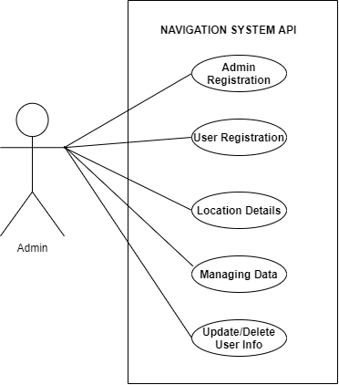

**USER-** 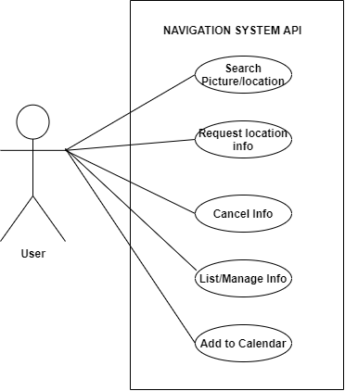

**Sequence Diagram :-**

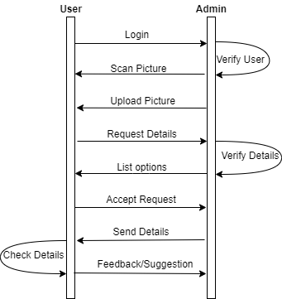

**Flow Diagram :-**

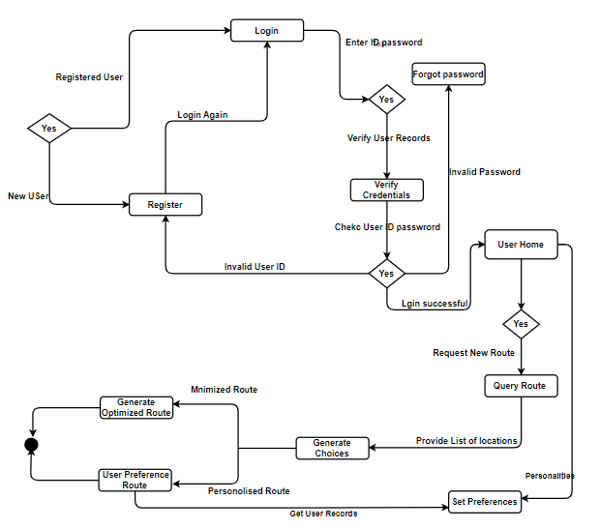

**5.DATABASE SCHEMA**

Database Schema is the overall Design of the Database. It is the skeleton structure that represents the logical view of the entire database. It tells how the data is organized and how the relations among them are associated.

Table Name:Listings

Description:To store the details of listings

| Fields | Data Types | Constraints |
| --- | --- | --- |
| id | INT | Primary Key |
| name | STR |  |
| photo | STR |  |
| description | TEXT |  |
| location | STR |  |
| address | STR |  |
| phone | STR |  |

TableName:User

Description:To store the details of users

| Fields | Data Types | Constraints |
| --- | --- | --- |
| id | INT | Primary Key |
| Username | STR |  |
| password | STR |  |
| first_name | STR |  |
| last_name | STR |  |
| email | STR |  |
| is_active | BOOL |  |
| doj | DATE |  |

TableName:Navigation Description:Includes means of travel, fares, and weather.

| Fields | Data Types | Constraints |
| --- | --- | --- |
| id | INT | Primary Key |
| travel mode | STR |  |
| fares | INT |  |
| weather | INT |  |
| Recommendations | STR |  |

TableName:Search

Description:Holds the information regarding the user searches.

| Fields | Data Types | Constraints |
| --- | --- | --- |
| id | INT | Primary Key |
| scanned_image | STR |  |
| location tag | INT |  |
| History | STR |  |

**6.DATA MODELING**

It is the process of creating a data model by applying certain formal techniques. A data model is a collection of concepts that can be used to describe the structure of a database, providing the necessary means to achieve this abstraction. By structure of a database we mean the data types, relationships, and constraints that apply to the data. Most data models also include a set of basic operations for specifying retrievals and updates on the database.

**E-R Diagram :-**

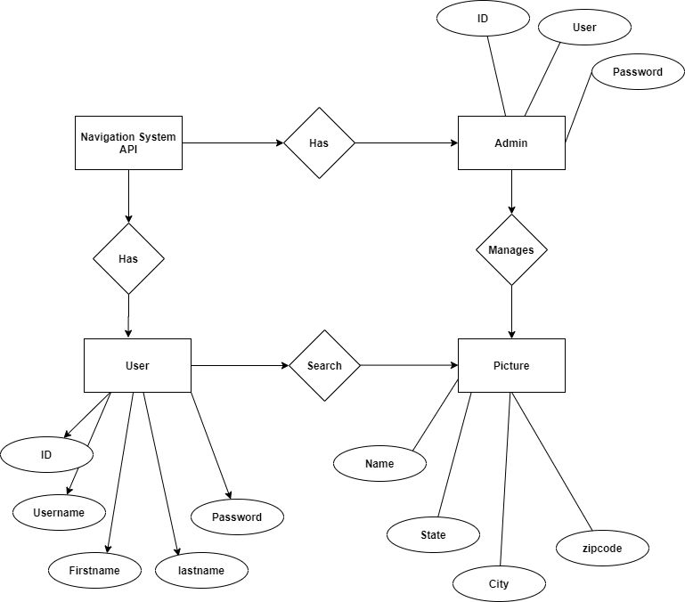

**7.CONCLUSION AND DISCUSSION**

**Self-Analysis of Project Viabilities**

Definitely, it is cheaper to use our application for navigation use because it is completely free.

**Problem Problem Encountered and Possible Solutions:**

**Scope Change:** It’s a mutual decision made by the team which involves adjustments to the scope, usage, timelines, other features of our applications as per the open source software .

**Hardware Limitations** In the case of low or exhausted disk space, the issue is solved by extending the disk space.

**8.SUMMARY**

In the development of our application, we first gather the requirements of the project and decide the time schedule to meet the deadlines. We also design documentation for our project. After the project design, we focus on the project execution phase. To ensure proper project control and monitoring, we must monitor it to track/debug errors and glitches, calculate key performance indicators and track variations from allotted cost and time. We finally close the project by delivering the finished project to the customer.

**REFERENCES:**

* Wikipedia(2020) <https://en.wikipedia.org/wiki/Firebase> [Accessed April 14th 2020].
* Wikipedia(2020)<https://en.wikipedia.org/wiki/Agile_software_development> [Accessed April 14th 2020].
* Wikipedia(2020)<https://en.wikipedia.org/wiki/Artificial_intelligence> [Accessed April 14th 2020].
* Wikipedia(2020)<https://en.wikipedia.org/wiki/Image_analysis> [Accessed April 14th 2020].
* <https://technical.ly/dc/2019/09/20/image-recognition-technology-artificial-intelligence/> [Accessed April 14th 2020].
* <https://thenextweb.com/artificial-intelligence/2018/07/18/a-beginners-guide-to-ai-computer-vision-and-image-recognition/> [Accessed April 14th 2020].